## BUG REPORT for Web App - <https://buggy.justtestit.org/>

**Total Bugs Found:** 15  
**Report Date:** April 15, 2025  
**Test Environment:**

* OS: Windows 10
* Browser: Chrome - Version 135.0.7049.85 (Official Build) (64-bit)

|  |  |  |  |
| --- | --- | --- | --- |
| **Bug #** | **Title** | **Severity** | **Status** |
| 001 | Registration form allows submission with whitespace-only values for first and last name fields | Medium | New |
| 002 | Incorrect error message validation shown when Last Name is cleared during registration | Low | New |
| 003 | “Author” name not displayed in car model comments after voting with a comment | Medium | New |
| 004 | Pagination input field not working on “Popular Make” and “Overall Rating” pages | Medium | New |
| 005 | Sorting for Model and Rank columns are not working on Popular Make (Lamborghini) page | Medium | New |
| 006 | “Overall Rating” Page pagination allows navigation beyond the total number of pages | Medium | New |
| 007 | Broken image link for Lancia Ypsilon car | Low | New |
| 008 | “Overall Rating” page “Rank” column header sort is not working properly | Low | New |
| 009 | Cosmetic Bug – Spacing between “Author” and “Comment” column is off in Car model page | Low | New |
| 010 | “Buggy Rating” header is not clickable in Popular Make page | Medium | New |
| 011 | Clicking on car model image redirects to home page instead of expected behavior | Low | New |
| 012 | “Overall Rating” and “Popular Make” page Table resets to default state when navigating back from row details | Medium | New |
| 013 | User not redirected to dashboard after logging in from registration page | Medium | New |
| 014 | Logged-in users can access and submit registration form via direct link | Medium | New |
| 015 | Navigation bar flickers/blinks with login navigation on Page Refresh | Low | New |
| 016 | User is redirected to Dashboard upon refreshing the Profile page | Low | New |

*\*Screen recording video will be included along with this file as test evidence for other bugs that has no screenshots*

**[BUG-001] Registration form allows submission with whitespace-only values for first and last name fields**

**Description:** The registration form accepts first and last name fields with only whitespace characters, resulting in invalid user data being submitted successfully

**Severity:** medium

**Priority:** medium

**Steps to Reproduce:**

1. Navigate to Registration page <https://buggy.justtestit.org/register>
2. Enter a valid login username
3. Enter whitespace value for firstname field
4. Enter whitespace value for lastname field
5. Enter valid password
6. Enter the same password from step 5
7. Click Register button

**Actual Result**: Registration is still successful even values for firstname and lastname fields are whitespaces. Validations for the fields are not working.

**Expected Result:** There should be validations for the firstname and lastname fields which should fail when user tries to register with whitespaces value

**[BUG-002] Incorrect error message validation shown when Last Name is cleared during registration**

**Description:** Clearing the lastname field triggers an incorrect error validation

**Severity:** Low

**Priority:** Low

**Steps to Reproduce:**

1. Navigate to Registration page <https://buggy.justtestit.org/register>
2. Enter a valid firstname
3. Enter a valid lastname
4. Clear the value entered in lastname field

**Actual Result**: “First Name is required” error message is shown even first name field has value

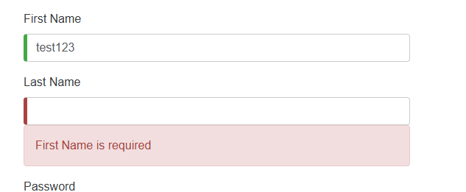

**Expected Result:** Error message should be “Last Name is required” since lastname field is cleared out and firstname field has value

**[BUG-003] “Author” name not displayed in car model comments after voting with a comment**

**Description:** After submitting a vote with a comment on a car model, the author name is missing in the comment section.

**Severity:** medium

**Priority:** medium

Pre-condition: User is registered and has an account

**Steps to Reproduce:**

1. Navigate to login page https://buggy.justtestit.org/
2. Enter a valid credentials
3. Navigate to Popular Make page
4. Select a car model where user has not yet voted (voting is still enabled)
5. Enter a comment
6. Click on Vote

**Actual Result**: Comment is added but no value in the Author column.

*Note: Happens to both in Popular Make and Overall Rating page car models.* ***Some*** *car models in Overall Rating page has Author values*

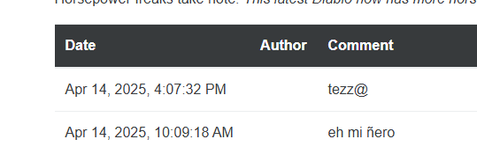

**Expected Result:** Author name should be displayed when voting with comment

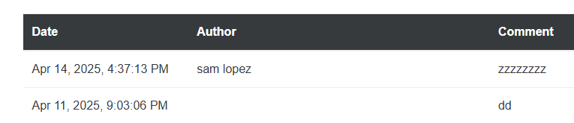

**[BUG-004] Pagination input field not working on “Popular Make” and “Overall Rating” pages**

**Description:** When a user enters a page number in the pagination input field and clicks outside the box (without pressing Enter), the value resets to the current page number. The page does not navigate to the entered page number.

**Severity:** medium

**Priority:** medium

Pre-condition: User is registered and has an account

**Steps to Reproduce:**

1. Navigate to login page https://buggy.justtestit.org/
2. Enter a valid credentials
3. Navigate to Popular Make page
4. Scroll down to pagination input field
5. Enter a page number to navigate
6. Click outside the pagination box
7. Repeat steps 1-6 for Overall Rating page

**Actual Result**: Page does not navigate to the entered page number. Page number resets back to the current page number.

**Expected Result:** The page should navigate to the entered page number and should reflect the correct page number in the pagination field once navigated successfully

**[BUG-005] Sorting for Model and Rank columns are not working on Popular Make (Lamborghini) page**

**Description:** When a user clicks on the Model and Rank column header on the Popular Make (Lamborghini) Page, it doesn’t sort even though column headers are clickable

**Severity:** medium

**Priority:** medium

Pre-condition: User is registered and has an account

**Steps to Reproduce:**

1. Navigate to login page https://buggy.justtestit.org/
2. Enter a valid credentials
3. Navigate to Popular Make page
4. Click on Make column header
5. Click on Rank column header

**Actual Result**: Car does not sort based on what user clicks on the column headers

*Note: Votes column header seems working but once it is clicked it doesn’t sort in ASC or DESC too*

**Expected Result:** Car list should be sorted based on what user clicks on the column headers

**[BUG-006] “Overall Rating” Page pagination allows navigation beyond the total number of pages**

**Description:** When the user clicks the “Next” page button or enters a page number greater than the total available pages (Which is 5 in the Overall Rating page) the system continues to navigate instead of stopping or restricting to the last page

**Severity:** medium

**Priority**: medium

Pre-condition: User is registered and has an account

**Steps to Reproduce:**

1. Navigate to login page https://buggy.justtestit.org/
2. Enter a valid credentials
3. Navigate to Overall Rating Page
4. Scroll down to pagination
5. Enter a page number beyond total number of pages
6. Click next page button until it passes the total number of pages

**Actual Result**: The pagination continues past the 5th page and pages after that are blank pages

**Expected Result:** The "Next" button should be disabled (or inactive) on the last page.

**[BUG-007] Broken image link for Lancia Ypsilon car**

**Severity:** Low

**Priority:** Low

Pre-condition: User is registered and has an account

**Steps to Reproduce:**

1. Navigate to login page https://buggy.justtestit.org/
2. Enter a valid credentials
3. Navigate to Overall Rating Page
4. Look for Lancia Ypsilon car model
5. Click the car model

**Actual Result**: Broken image icon displayed for Lancia Ypsilon car

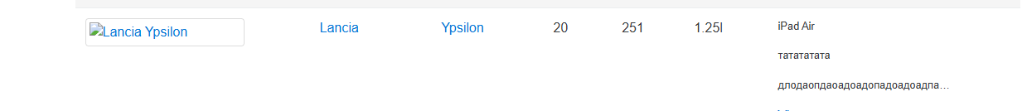

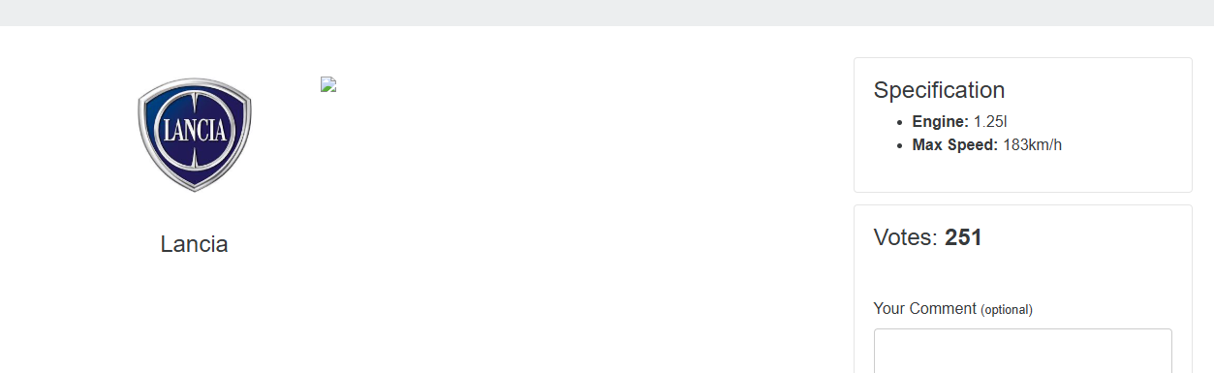

**Expected Result:** Should not display broken image icon

**[BUG-008] “Overall Rating” page “Rank” column header sort is not working properly**

**Description:** When the user clicks Rank column header to sort it sorts differently

**Severity:** Low

**Priority:** Medium

Pre-condition: User is registered and has an account

**Steps to Reproduce:**

1. Navigate to login page https://buggy.justtestit.org/
2. Enter a valid credentials
3. Navigate to Overall Rating Page
4. Click on the Rank column header to sort differently

**Actual Result**: Sorting behavior for Rank column header is odd as it sorts randomly and when in other pages it won’t sort once clicked again

**Expected Result:** Should be able properly or sort in ascending or descending order

**[BUG-009] Cosmetic Bug – Spacing between “Author” and “Comment” column is off in Car model page**

**Severity:** Low

**Priority:** Low

Pre-condition: User is registered and has an account

**Steps to Reproduce:**

1. Navigate to login page https://buggy.justtestit.org/
2. Enter a valid credentials
3. Navigate to Overall Rating Page
4. Search and click for Alfa Romeo Mito model

**Actual Result**: Spacing is not even between Author and Comment column

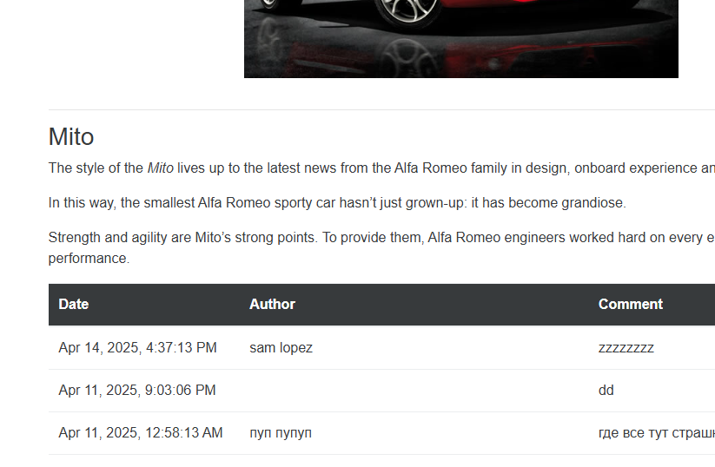

**Expected Result:** Spacing should be even between Author and Comment column

**[BUG-010] “Buggy Rating” header is not clickable in Popular Make page**

**Severity:** medium

**Priority:** medium

Pre-condition: User is registered and has an account

**Steps to Reproduce:**

1. Navigate to login page https://buggy.justtestit.org/
2. Enter a valid credentials
3. Navigate to Popular Make page (Lamborghini)
4. Click on the “Buggy Rating” Header at most top left

**Actual Result**: “Buggy Rating” Header is not clickable

**Expected Result:** “Buggy Rating” Header should be clickable and should navigate you to home page when clicked

**[BUG-011] Clicking on car model image redirects to home page instead of expected behavior**

**Description:** When a user clicks on a car model image, they are unexpectedly redirected to the home page. Could be an incorrect link.

**Severity:** Low

**Priority:** Medium

Pre-condition: User is registered and has an account

**Steps to Reproduce:**

1. Navigate to login page https://buggy.justtestit.org/
2. Enter a valid credentials
3. Navigate to Popular Make page (Lamborghini)
4. Select a car model
5. Click the car model image

**Actual Result**: User is redirected to home page

**Expected Result:** Clicking the car model image should redirect to the car's detail page or perform the correct intended action.

**[BUG-012] “Overall Rating” and “Popular Make” page Table resets to default state when navigating back from row details**

**Description:** When a user interacts with the table (sorts, paginates) and clicks on a row, the table resets to the default page and sort when returning, instead of preserving the previous state.

**Severity:** medium

**Priority:** Medium

Pre-condition: User is registered and has an account

**Steps to Reproduce:**

1. Navigate to login page https://buggy.justtestit.org/
2. Enter a valid credentials
3. Navigate to Overall rating page
4. Click on next page button in pagination
5. Click on Make column header to sort
6. Select a car model
7. Navigate back to Overall Rating page table list
8. Repeat steps 3 -7 for Popular Make page

**Actual Result**: Table state is not save the current page number and sort order is reset

**Expected Result:** User preferences should be saved (Table state, sorting and page number should be saved)

**[BUG-013] User not redirected to dashboard after logging in from registration page**

**Description:** When a user logs in from registration page it doesn’t redirect to dashboard page. Instead, it is still on the registration page

**Severity:** Medium

**Priority:** Medium/High

Pre-condition: User is registered and has an account

**Steps to Reproduce:**

1. Navigate to login page https://buggy.justtestit.org/register
2. Enter a valid credentials

**Actual Result**: User is not redirected to dashboard page

**Expected Result:** User should be redirected to dashboard/home page

**[BUG-014] Logged-in users can access and submit registration form via direct link**

**Description:** When a user logs in, registration page is still accessible and user is able to submit a registration form successfully

**Severity:** Medium

**Priority:** High

Pre-condition: User is registered and has an account

**Steps to Reproduce:**

1. Navigate to login page https://buggy.justtestit.org/
2. Enter a valid credentials
3. Access Registration page via direct link <https://buggy.justtestit.org/register>
4. Fill registration necessary fields
5. Click Register

**Actual Result**: Logged in user was able to access registration page via direct link and was able to submit a registration form successfully

**Expected Result:** Logged in user should not allowed to access registration page via direct link as it is intended for users who is not registered

**[BUG-015] Navigation bar flickers/blinks with login navigation on Page Refresh**

**Description:** When a user logs in and refresh the page, the login navigation shows/flickers for a bit

**Severity:** Low

**Priority:** Low

Pre-condition: User is registered and has an account

**Steps to Reproduce:**

1. Navigate to login page https://buggy.justtestit.org/
2. Enter a valid credentials
3. Refresh the page

**Actual Result**: Login navigation bar flickers/blinks a bit after refreshing the page

**Expected Result:** Navigation bar should not blink or flickers when page is refreshed

**[BUG-016] User is redirected to Dashboard upon refreshing the Profile page**

**Severity:** Low

**Priority:** Medium

Pre-condition: User is registered and has an account

**Steps to Reproduce:**

1. Navigate to login page https://buggy.justtestit.org/
2. Enter a valid credentials
3. Navigate to Profile page
4. Refresh the page

**Actual Result**: User is redirected to dashboard page

**Expected Result:** User should stay in Profile page when page is refreshed